

Hardware Configuration Index
For The
Avionics Passenger Counter FPGA
Document No: 800-HCI-01
Revision: 0.1

__________________________________________________ |  |  | ___________
Project Manager |  | Date
__________________________________________________ |  | ___________
Technical Project Lead |  | Date
__________________________________________________ |  | ___________
Principal Design Engineer |  | Date
__________________________________________________ |  | ___________
Principal Quality Engineer |  | Date

Notice
This document and the information contained herein are the property of Airworthiness Certification Services LLC. Any reproduction, disclosure or use thereof is prohibited except as authorized in writing by Airworthiness Certification Services LLC. Recipient accepts the responsibility for maintaining the confidentiality of the contents of this document.

REVISIONS
Rev. | Reason/Description | Requested/  Changed By | Date
0.1 | Initial Draft | N/A

Table of Contents

Section Page

1.0 INTRODUCTION 4
1.1 Purpose 4
1.2 Scope 4
1.3 Acronyms and Abbreviations 5
1.4 Applicable Documents 6
1.4.1 External Documents 6
1.4.2 Internal Documents 6
2.0 HARDWARE PRODUCT 7
2.1 Product Overview 7
2.2 Product Identification 7
3.0 HARDWARE REVISION HISTORY 8
3.1 Version Description 8
4.0 HARDWARE LIFE CYCLE DATA 9
4.1 VHDL Files 10
4.2 FPGA Project File 10
4.3 Constraint Files 10
4.4 VHDL Test bench files 10
4.5 Programming File 10
4.6 Hardware Configuration Environment Tools 11
5.0 ARCHIVE AND RELEASE MEDIA 11
6.0 Build Procedure 12
6.1 Accepted Warnings 18

1.0 INTRODUCTION

1.1 Purpose

This document identifies the hardware configuration of the Avionics Passenger Counter FPGA which is one of two parts which are in the Avionics Passenger Counter system II. This document has been prepared in accordance with the requirements of RTCA/DO-254. This section defines the specific revisions of all components and instructions necessary to build the firmware for the Passenger Counter FPGA.

1.2 Scope

This document will be used by the certification authority to identify the hardware configuration of the product. This Hardware Configuration Index (HCI) complies with the documentation requirements of RTCA/DO-254.

1.3 Acronyms and Abbreviations

AIMS Action Item Management System
ALU Arithmetic Logic Unit
ARP Aerospace Recommended Practice
ASIC Application Specific Integrated Circuit
DRMS Document Review Management System
HC1 Hardware Control Category 1
HC2 Hardware Control Category 2
COTS Commercial-Off-The-Shelf
EUROCAE European Organization for Civil Aviation Equipment
FAR Federal Aviation Regulations
FFP Functional Failure Path
FFPA Functional Failure Path Analysis
FHA Functional Hazard Assessment
F-FMEA Functional Failure Modes and Effects Analysis
FPGA Field Programmable Gate Array
FTA Fault Tree Analysis
HDL Hardware Description Language
JAR Joint Aviation Requirements
LRU Line Replaceable Unit
PHAC Plan for Hardware Aspects of Certification
PLD Programmable Logic Device
PSSA Preliminary System Safety Assessment
RTMS Requirements Traceability Management System
SAE Society of Automotive Engineers
SC Special Committee
SSA System Safety Assessment
WG Working Group

1.4 Applicable Documents

The following documents are listed for reference only. Each document is applicable to this plan only to the extent specified herein.

1.4.1 External Documents

RTCA/DO-254 Design Assurance for Airborne Electronic Hardware

FAA Order 8110.4C Type Certification

AC 20-152 Advisory Circular, RTCA Inc., Document DO-254, Design Assurance for Airborne Electronic Hardware

1.4.2 Internal Documents

See section 5.0 of this document for all the life cycle data items and there versions produced to comply with the objectives and plans for DO-254.

2.0 HARDWARE PRODUCT

The hardware is identified from requirements listed in the System Requirements document for the Avionics Passenger Counter.

2.1 Product Overview
The Avionics Passenger Counter is a module that will keep track of how many passengers are currently in the aircraft/cabin. The current number of passengers in the cabin will be displayed on a display panel in real-time. The system will have a keypad entry so that the flight attendant can enter a passenger headcount correction/adjustment. The Passenger Counter FPGA is one of two FPGAs in this system which provides an 8 bit counter function and outputs the count to a display and PIC processor for ARINC 429 transmission.

2.2 Product Identification

The following hardware and hardware part numbers will be used to describe the product.

Hardware Part Number | Nomenclature
C800-1001-01 | Passenger Counter FPGA, 8 Bit Counter

3.0 HARDWARE REVISION HISTORY

This section identifies previous hardware releases and change summaries. Hardware changes are further identified in the Change Impact Analysis. This process is used to determine the potential impact of the change on continued operational safety of the aircraft.

The analysis also provides a basis for determining the extent of certification authority involvement. If the change is determined to be Minor, certification authority involvement will be relatively minimal; however, if the change is determined to be Major, certification authority involvement and oversight will be increased.

Version Description

Table 3-1 below summarizes the firmware release history for this device.

Date | Hardware Part Number | Programming File | CheckSum | Notes
03 Jan 2009 | C800-1001-01 | EightBitCounter.bit | A8D44530 | Rev New release
12 July 2011 | C800-1001-02 | EightBitCounter.bit | F8D00740 | Updated per ECO 12345 to add PIC processor interface

4.0 HARDWARE LIFE CYCLE DATA

Hardware Life Cycle Data consists of the data or artifacts produced during life cycle development of the product. The data below has been produced to support the Passenger Counter FPGA.

These artifacts are identified below:

Hardware Design Life Cycle Data |  | DO-254 |  | Note 1  Submit |  | HW  Category |  | Data Items  Passenger Counter FPGA
Hardware Plans | 10.1
Plan for Hardware Aspect of Certification | 10.1.1 |  | S |  | HC1 |  | 800-PHAC-01 Rev A  (this document)
Hardware Design Plan (HDP) | 10.1.2 |  |  |  | HC2 |  | 800-PHAC-01 Rev A  (this document)
Hardware Validation Plan | 10.1.3 |  |  |  | HC2 |  | 800-HVVP-01 Rev A
Hardware Verification Plan | 10.1.4 |  | S |  | HC2 |  | 800-HVVP-01 Rev A
Hardware Configuration Management Plan | 10.1.5 |  |  |  | HC2 |  | 800-HCMP-01 Rev A
Hardware Process Assurance Plan | 10.1.6 |  |  |  | HC2 |  | 800-HPAP-01 Rev A
Hardware Design Standards | 10.2
Requirements Standards | 10.2.1 |  |  |  | HC2 |  | 800-HRS-01 Rev -
Hardware Design Standards | 10.2.2 |  |  |  | HC2 |  | 800-PHAC-01 Rev A  (this document)
Validation and Verification Standards | 10.2.3 |  |  |  | HC2 |  | 800-HVVP-01 Rev A
Hardware Archive Standards | 10.2.4 |  |  |  | HC2 |  | 800-HRD-01 Rev B
Hardware Design Data | 10.3
Hardware Requirements | 10.3.1 |  |  |  | HC1 |  | 800-HRD-01 Rev B
Hardware Design Representation Data | 10.3.2
Conceptual Design Data | 10.3.2.1 |  |  |  | HC2 |  | 800-HRD-01 Rev A
Detailed Design Data | 10.3.2.2
Top-level Drawing | 10.3.2.2.1 |  | S |  | HC1 |  | 800-HCI-01 (this document)
Assembly Drawings | 10.3.2.2.2 |  |  |  | HC1 |  | 800-HCI-01(this document)
Installation Control Drawings | 10.3.2.2.3 |  |  |  | HC1 |  | 800-HCI-01(this document)
Hardware/Hardware Interface Data | 10.3.2.2.4 |  |  |  | HC1 |  | 800-HRD-01 Rev A
Validation and Verification Data | 10.4
Hardware Traceability Data | 10.4.1 |  |  |  | HC2 |  | 800-HTR-01 Rev -
Hardware Review and Analysis Procedures | 10.4.2 |  |  |  | HC1 |  | 800-HTP-01 draft
Hardware Review and Analysis Results | 10.4.3 |  |  |  | HC2 |  | 800-HTR-01 draft
Hardware Verification Test Procedure | 10.4.4 |  |  |  | HC2 |  | 800-HTP-01 draft
Hardware Verification Test Results | 10.4.5 |  |  |  | HC2 |  | 800-HTR-01 draft
Problem Reports | 10.6 |  |  |  | HC2 |  | Part of web development PR system
Hardware Configuration Management Records | 10.7 |  |  |  | HC2 |  | Part of web development PR system
Hardware Process Assurance Records | 10.8 |  |  |  | HC2 |  | CCB records, Checklists, Review Minutes, Audit Reports
Hardware Accomplishment Summary | 10.9 |  | S |  | HC1 |  | 800-HAS-01 draft
Table 6-1 Passenger Counter FPGA Hardware Life Cycle Documents
- Data that should be submitted is indicated by an S in the Submit column. HC1 and HC2 data used for certification need not be submitted but should be available. Refer to DO-254 Section 7.3

4.1 VHDL Files

Combined VHDL files, these files are loaded when opening the project file in the Xilinx ISE tool. The date refers to the operating system property of the source file which is always updated whenever the file is stored.

File Name | Version | Date | Comment
EightBitCounter.vhd | 1.0 | 6/3/2007 | VHDL design file

FPGA Project File

FPGA project file used by Xilinx ISE

File Name | Version | Date | Comment
TammyFAAClass.ise | 1.0 | 1/3/2009 | FPGA project file

Constraint Files

FPGA constraint file used for FPGA guiding the FPGA synthesis, place and routed processes.

File Name | Version | Date | Comment
EightBitCounter.ucf | 1.0 | 6/4/2007 | FPGA constraint file

VHDL Test bench files

Combined VHDL files (entity and architecture), for verification test bench

File Name | Version | Date | Comment
EightBitCounter_tb.vhd | 1.0 | 1/3/2009 | VHDL test bench file

Programming File

ACME Co. Secure Web Management System and Visual Source Safe (VSS) library contains all the source files and resulting build and script files necessary for regeneration of the programming file for the Passenger Counter FPGA.

The FPGA device is SRAM technology based and the configuration data is held externally.
Programming File: EightBitCounter.bit Date 1/3/2009

EightBitCounter.bit is the input file into the SFV Checker checksum generation tool.
Checksum: F8D00740

Hardware Configuration Environment Tools

The following tools where used for the FPGA build, development and verification process:

Development and Verification Tools

Activity | Tool | Version
Design Entry | Aldec Active HDL,  Mentor Graphics ViewLogic | 6.3  V7.0
Synthesis | Xilinx ISE | 6.3g
Place & Route | Xilinx ISE | 6.3g
Simulation | Active HDL | 4.0
Device Programming | Xilinx iMPACT | 6.3.0.1i
Source Revision Control | Visual Source Safe | 6.0
Check Generation | SFV Checker | V1.19

5.0 ARCHIVE AND RELEASE MEDIA

Standard backup archive and retrieval processes will be followed during development. These procedures will ensure that all of the Hardware Life Cycle Data is archived to a tape or CD. At a minimum, archival will be done weekly and after each release. To ensure that the archival data is complete and accurate the following will be performed.

- Two copies of each release archival will be created.

- Each tape or CD will be verified, at creation, as valid and password protected. The final
release will be installed, for verification purposes, on a machine that has been formatted and Windows NT installed.

- One tape or CD will be stored on the premises in a secure location.

- One tape or CD will be stored off-site in a secure location.

- The archival tapes will be regenerated every four years, by Alternative Avionics, to ensure the integrity of the media and data.

Each tape or CD will have a label with the following information:

- Date Created
- Version number of the of the release
- Description of what is on the tape or CD

For final release, an installable version of the operating system and all development and verification tools, defined in the SECI, must be included.

Build Procedure

Steps to compile a Xilinx project

- Invoke Xilinx ISE
- From Xilinx command bar left-click File -> Open Project and select TammyFAAClass.ise in the design directory.
- From the Source Window make sure EightBitCounter is highlighted
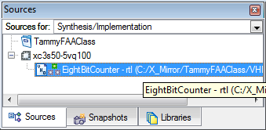

- From the Xilinx Process window right-click Synthesize – XST -> Properties then highlight Synthesis Options and select options as shown below
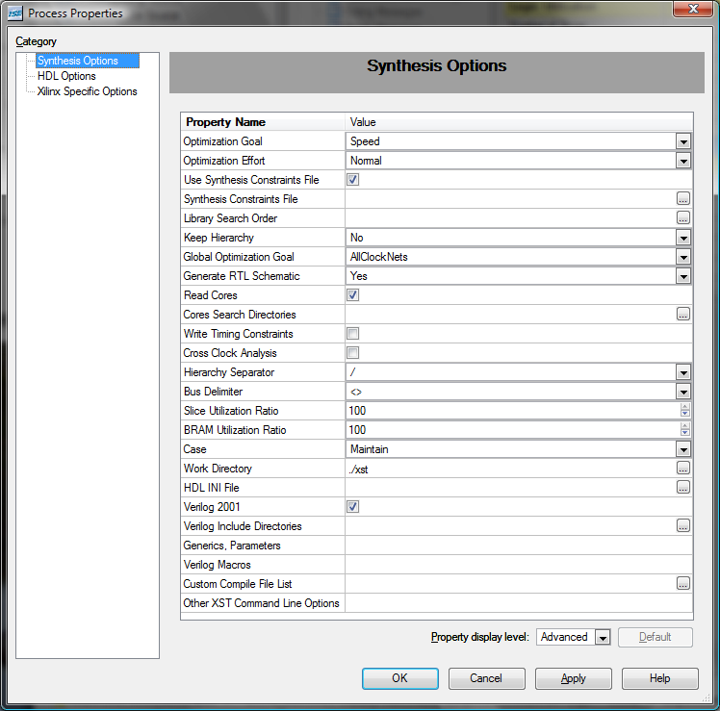

- Next highlight HDL Options and select options as shown below
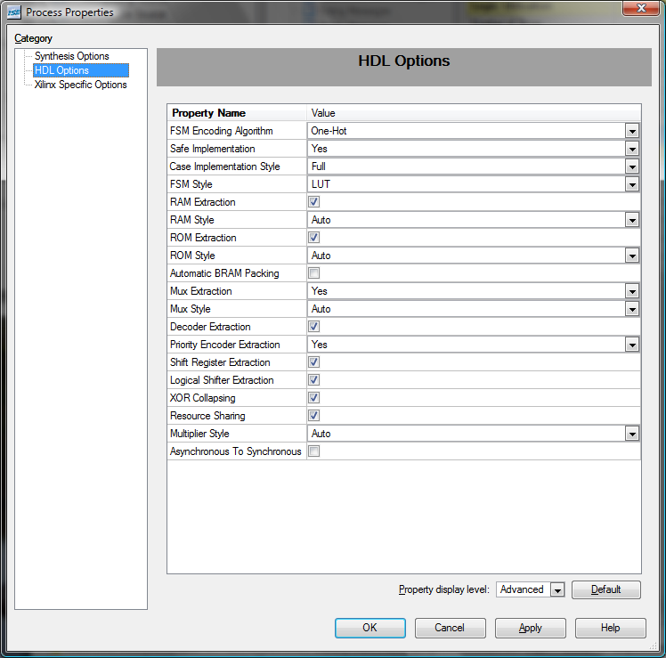

- Next highlight Xilinx Specific Options and select options as shown below
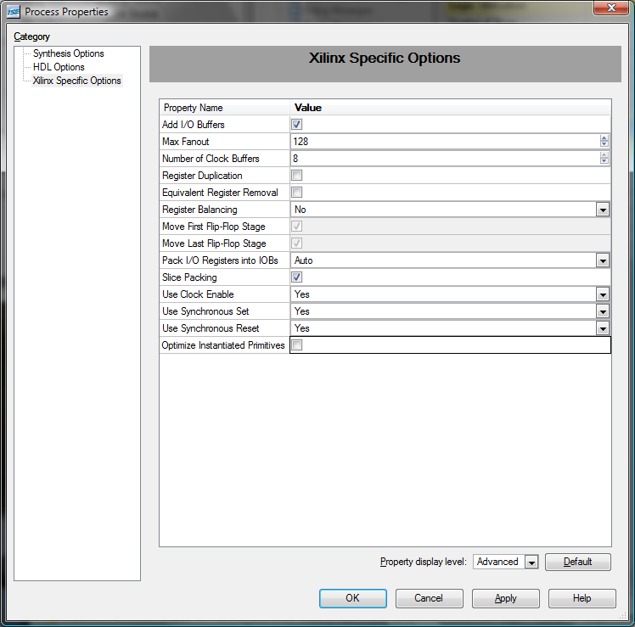
Select OK

- From the Xilinx Process window right-click Synthesize – XST -> Run
- From the Xilinx Process window right-click Implement Design -> Properties
- From the Process Properties window highlight Map Properties and select options as shown
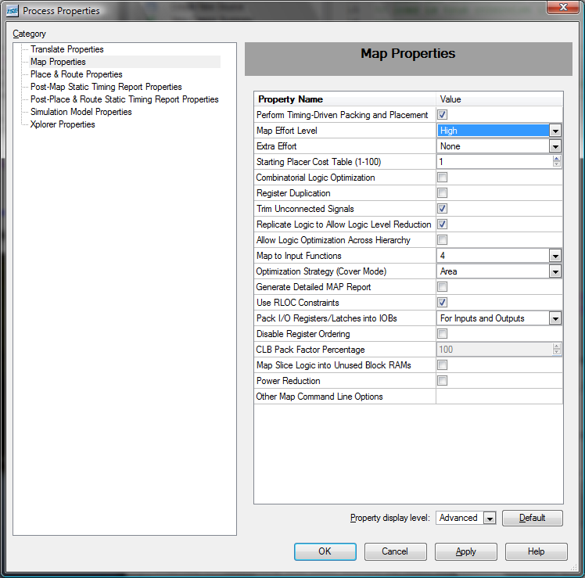

- From Process Properties window highlight Place & Route Properties and select options as shown
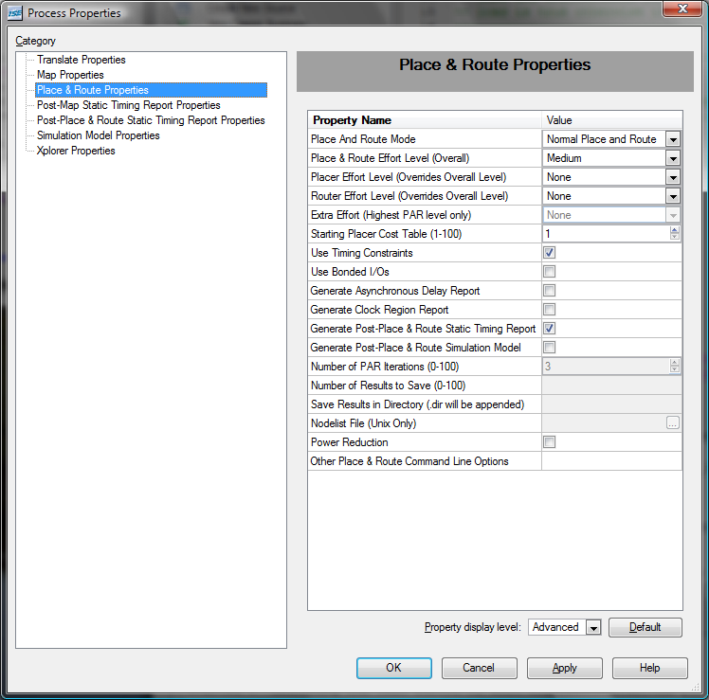
Select OK

- From the Xilinx Process window right-click Implement Design -> Run
This will place and route the design.
- From the Xilinx Process window right-click Generate Programming File -> Properties and highlight General Options as shown:
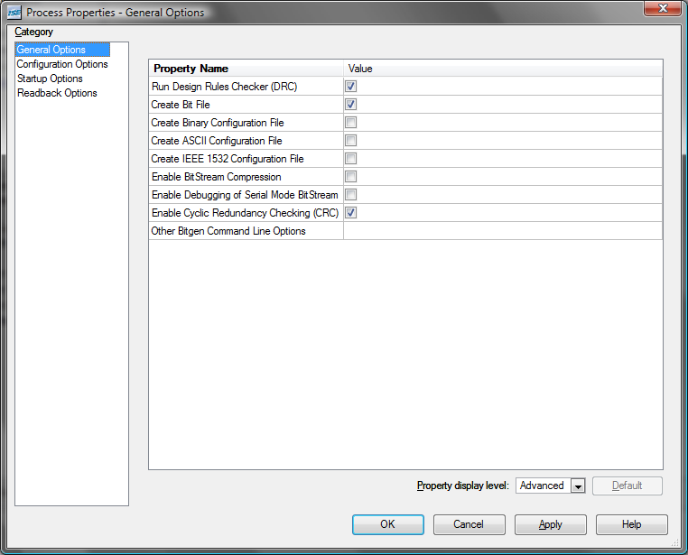

- From the Xilinx Process window right-click Generate Programming File -> Run
This will create the EightBitCounter.bit file.

6.1 Accepted Warnings

WARNING Par:434 - The PAR Effort Level option value "Medium" (-ol med) is being deprecated in the next major software release. Please consider using the value of "Standard" to minimize runtime or "High" to achieve the best performance.

